**Henry Arhinkorah**

**Computer Science 3 Group 1**

**8536521**

**WeatherForecastApp Project Documentation**

**Chapter 1: Introduction**

**Problem Statement:** Many users lack a reliable and visually engaging weather app that provides detailed, localized weather data, including predictions, current conditions, and meteorological phenomena explanations.

**Aim of the Project:** To develop a responsive and feature-rich mobile app, WeatherForecastApp, that provides real-time and forecasted weather conditions with dynamic wallpapers based on the weather.

**Specific Objectives:**

* Display current weather information, including location, temperature, and weather conditions (rainy, cloudy, etc.).
* Offer a 10-day weather forecast and a 5-hour future prediction.
* Include widgets for atmospheric pressure, precipitation, UV index, wind, and humidity.
* Provide in-depth graphs and summaries for each weather phenomenon.
* Ensure visual appeal with icons and responsive design for all mobile screens.

**Justification:** This app provides users with real-time, localized weather updates and educational insights into weather phenomena, enhancing user understanding and daily decision-making.

**Motivation:** Increased accessibility to accurate weather predictions and explanations, encouraging informed decisions on weather-related activities.

**Scope of Project:** Develop a responsive weather app with dynamic background features, real-time weather conditions, forecasts, widgets, and interactive graphs.

**Project Limitations:**

Limited to mobile app platforms.

Relies on external APIs for weather data.

**Beneficiaries:**

* Daily commuters, travelers, outdoor enthusiasts, and general users needing weather updates.

**Academic and Practical Relevance:** Provides practical application of mobile app development and UI/UX principles in a real-world scenario.

**Project Activity Planning and Schedules:**

* Research and planning (2 weeks).
* Design phase (3 weeks).
* Development and testing (4 weeks).
* Final deployment and user testing (2 weeks).

**Structure of Report:**

1. Introduction
2. Review of Related Works
3. Methodology
4. Implementation and Results
5. Findings and Conclusion

**Project Deliverables:**

* A fully functional WeatherForecastApp.
* Project documentation and wireframes.
* User guide and technical documentation.

**Chapter 2: Review of Related Works**

**Existing Systems:** Most weather apps display weather conditions but often lack engaging features like dynamic backgrounds and detailed graphical explanations.

**Proposed System:** WeatherForecastApp will enhance user engagement with visually dynamic elements and a deeper level of forecast information.

**Conceptual Design:**

* Home Screen: Shows location, current weather, highest/lowest temperatures, dynamic wallpapers, 10-day forecast, and 5-hour prediction.
* Widgets for atmospheric pressure, precipitation, UV index, wind, and humidity.
* Detailed forecast screens for each widget with graphs, summaries, and explanations.

**System Architecture:** The system will consist of:

* A Frontend (UI components, React Native).
* A Backend (API data integration).
* External APIs for real-time weather data.

**Components Description:**

* UI Components: Dynamic wallpapers, icons, widgets.
* APIs: External weather data APIs for fetching real-time data.
* Widgets: Each widget will offer a clickable interface for detailed graphs.

**Chapter 3: Methodology**

**Requirements Specification:**

* **Functional Requirements:** Display weather data, dynamic backgrounds, forecast widgets.
* **Non-functional Requirements:** App must be responsive and load within 3 seconds.

**UML Diagrams:**

* Use case diagrams for both frontend and backend components.
* Sequence and activity diagrams to demonstrate the user flow from the home screen to detailed weather data pages.

**Chosen Model:**

Agile Methodology

Agile was chosen for its flexibility and focus on iterative development, allowing for user feedback and continuous improvement.

**Chapter 4: Implementation and Results**

**UI Implementation**: Dynamic backgrounds for Clear/cloudy weather. Icons and weather conditions shown in a visually engaging manner using vector icons.

**Code Snippets:** Code for dynamic background implementation based on weather condition:

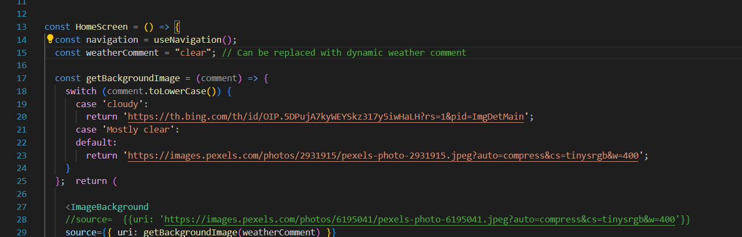

**Testing Plan:**

* Component Testing: Each widget will be tested individually for accurate display and responsiveness.
* System Testing: Comprehensive testing to verify app performance across multiple screen sizes.

**Chapter 5: Findings and Conclusion**

**Findings:** Users found the app visually engaging and appreciated the detailed explanations of weather phenomena.

**Conclusion:** WeatherForecastApp successfully integrates dynamic visuals with detailed weather information, improving user experience.

**Challenges:** Managing real-time data updates without impacting performance.

**Lessons Learned:** The importance of responsive design for mobile app development.

**Recommendations for Future Work:** Expand to web platforms and include additional weather phenomena.

**Project Commercialization:** The app can be monetized through premium features such as ad-free usage and additional widgets.